Back-Propagation Neural Network Algorithm
Inp 1

Inp 2

Inp 3

Inp n
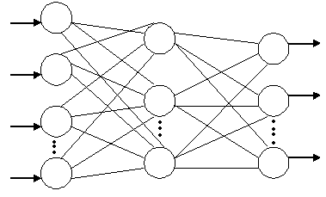
Out1

Out 2

Out 8
Fig. 1: Three layer neural network

The first step is initializes the weight vectors Wij and W_{jk} and the threshold values for each PE (processing element) with minimum random numbers.

In second step, the network provides the input patterns and the desired respective output patterns.

In third step, the input patterns are connected to the hidden PEs through the weights W_{ij.} In the hidden layer, each PE computed the weighted sum according to the equation,
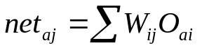
(1)

Where Oai is the input of unit i for pattern number a. The threshold of each PE was then added to its weighted sum to obtain the activation active ( j ) of that PE i.e.
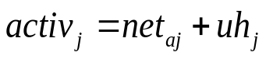
(2)

Where uh_{j} is the hidden threshold weights for j^{th} PEs. This activation determined whether the output of the respective PE was either 1 or 0 (fires or not) by using a sigmoid function,
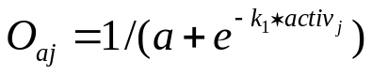
(3)

Where k₁ is called the spread factors, these O_{aj} were then served as the input to the output computation. Signal O_{aj} were then fan out to the output layer according to the relation,
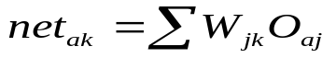
(4)

And the output threshold weight uo_{k} for k^{th} output PEs was added to it to find out the activation activo_{k}
(5)
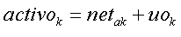
The actual output O_{ak} was computed using the same sigmoid function which was
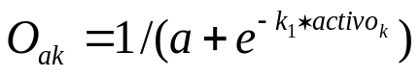
(6)

Here another spread factor k₂ has been employed for the output units.
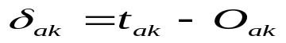In the second stages, after computing the feed-forward propagation, an error was computed by comparing the output O_{ak} with the respective target t_{ak} , i.e.
(7)

This error was then used to adjust the weights vector W_{jk} using the equation,
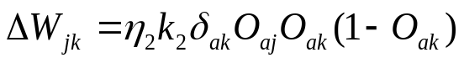
(8)

Where 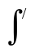(activo_{k} )=k₂ O_{ak} (1- O_{ak} ), the derivation of sigmoid function.
The weight vector W_{jk} was then adjusted to
(9)
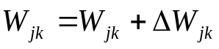
For the threshold weight of the output PE, similar equation was employed,
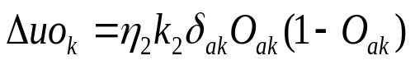
(10)

and the new threshold weight equaled as,
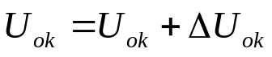
(11)

In the next step, this error and the adjusted weight vector W_{jk} were feedback to the hidden layer adjust the weight vector W_{ij} and threshold weight uh_{j}. In this layer, the weight vector W_{ij} was computed by using equation,
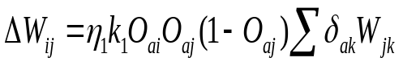
(12)
Where (activh_{j}) =k₁ O_{aj} (1- O_{aj} ). The weight W_{ij} was then adjusted to
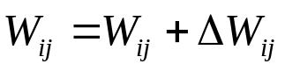
(13)

For the threshold weights of the hidden PEs, similar equation was employed, 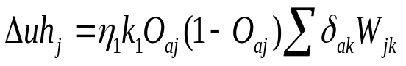
(14)
and the new threshold were calculated
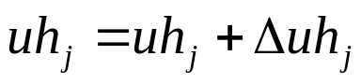
(15)

Calculating Errors:

After getting the output from the output layer, we calculate the error according to the targeted output in the following error calculating formula,
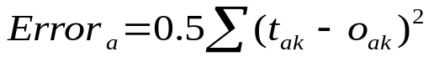
(16)

